**Module-3: Docker – I Assignment – 4**

You have been asked to: Create a dockerfile with the following specs:

● Ubuntu container   
● Apache2 installed

● Apache2 should automatically run once the container starts Submit the dockerfile, for assignment completion

**Steps done :**

Creating a directory for assign4 and created a dockerfile inside the created directory

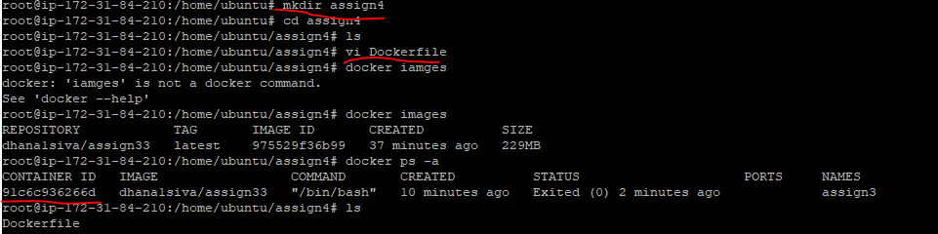  
  
Below are the cmds provided in Docker file

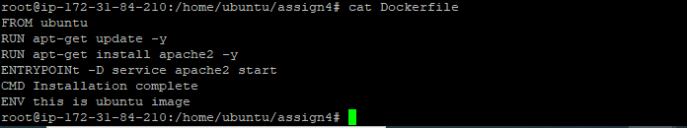

Building a image from the created dockerfile

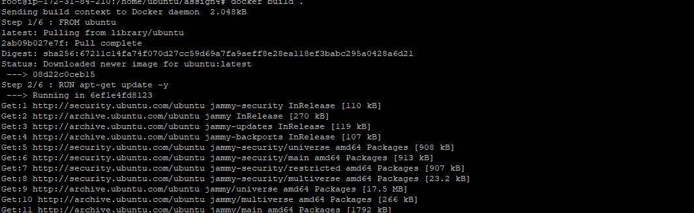

Docker images has been created with the help of docker file commands

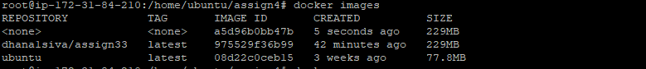

Post creation of image, ran the container out of that image



Docker container has been created with help of docker images previously



------------------------------------------------------------------------------------------------------------------------------------------